**Dynamic Insights: Unraveling Trends and Forecasting Housing Prices with Power BI in the Housing Price Prediction**

**Power BI: Overview**

Power BI is a business intelligence (BI) platform that helps organizations transform their data into actionable insights. It provides a suite of tools and services for data acquisition, transformation, modeling, visualization, and analysis. With Power BI, users can create interactive reports and dashboards that share insights across the organization.

Key Features of Power BI

**Installing Power BI Desktop:**

**Download Power BI Desktop:**

* Visit the official Power BI website at [powerbi.microsoft.com](https://powerbi.microsoft.com/" \t "https://chat.openai.com/c/_new).
* Navigate to the "Products" tab and select "Power BI Desktop."
* Click on "Download free" to initiate the download.

**Run the Installer:**

1. Once the download is complete, locate the downloaded installer file (typically named "PBIDesktopSetup.exe").
2. Double-click on the installer file to initiate the installation process.

**Accept License Terms:**

The installer will prompt you to review and accept the license terms. Read through the terms and click "Accept" if you agree.

**Choose Installation Location:**

Select the destination folder where you want to install Power BI Desktop. The default location is usually recommended, but you can choose a different location if needed.

**Select Additional Tasks (Optional):**

Optionally, you can choose to create desktop shortcuts and associate file types with Power BI Desktop. Adjust these settings based on your preferences.

**Install:**

* Click the "Install" button to begin the installation process. The installer will copy necessary files to your computer.

**Launch Power BI Desktop:**

Once the installation is complete, you can choose to launch Power BI Desktop immediately. Check the box labeled "Launch Power BI Desktop" and click "Finish."

**Verify Installation:**

Power BI Desktop should now be installed on your computer. You can verify the installation by opening the application and exploring its features.

**Updating Power BI Desktop:**

It's advisable to keep Power BI Desktop up-to-date to access the latest features and improvements. To update Power BI Desktop:

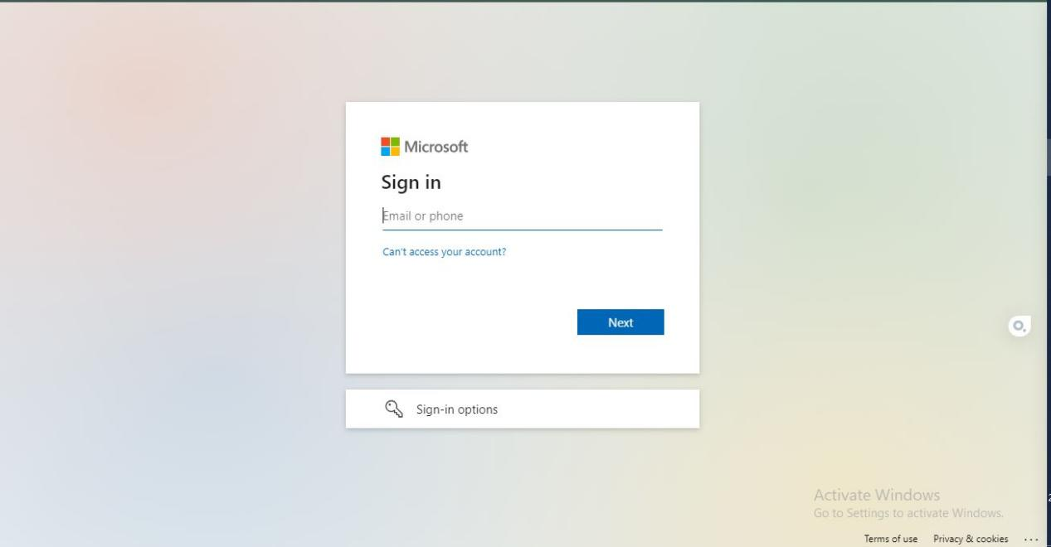

1. Open Power BI Desktop.
2. Click on "Help" in the top menu.
3. Select "Check for updates."
4. If an update is available, follow the on-screen instructions to download and install the latest version.

**Data acquisition:** Power BI can connect to a wide range of data sources, including on-premises databases, cloud-based applications, and Excel spreadsheets.

**Data transformation:** Power BI Query Editor provides a powerful tool for cleaning, shaping, and transforming data.

**Data modeling:** Power BI Desktop allows users to create data models that represent their data in a way that is easy to analyze.

**Data visualization:** Power BI offers a wide range of data visualization options, including charts, graphs, and maps.

Data analysis: Power BI provides a number of features for analyzing data, such as drill-down capabilities, filters, and slicers.

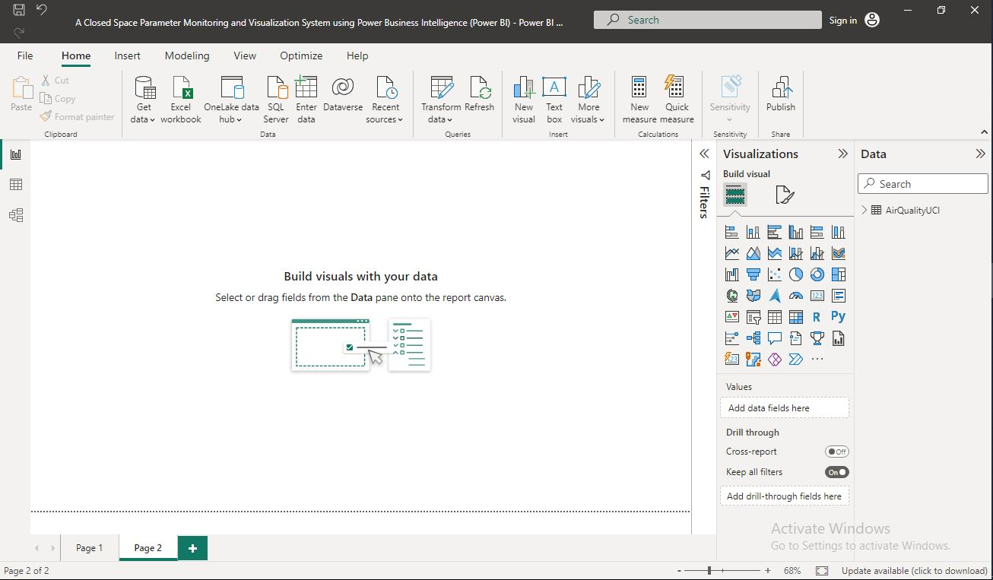

**Benefits of Power BI**

Improved decision-making: Power BI helps organizations make better decisions by providing data-driven insights.

Increased productivity: Power BI can help organizations save time and money by automating tasks and providing self-service BI capabilities.

Enhanced collaboration: Power BI facilitates collaboration by enabling users to share and discuss insights.

Improved data governance: Power BI can help organizations improve data governance by providing a centralized platform for managing data.

**Sales:** Power BI can be used to track sales performance, identify trends, and optimize sales strategies.

**Marketing:** Power BI can be used to measure the effectiveness of marketing campaigns, identify target audiences, and optimize marketing spend.

**Customer service:** Power BI can be used to track customer satisfaction, identify areas for improvement, and improve customer retention.

**Finance**: Power BI can be used to track financial performance, identify cost-saving opportunities, and make informed financial decisions.

**Operations:** Power BI can be used to track operational efficiency, identify bottlenecks, and improve processes.

Power BI is a powerful tool that can help organizations transform their data into a strategic asset. By leveraging Power BI, organizations can make better decisions, increase productivity, enhance collaboration, and improve data governance.

Power BI is a versatile platform that can be used by organizations of all sizes, from small businesses to large enterprises. It is a cloud-based platform that is easy to use and affordable.

If you are looking for a way to transform your data into actionable insights, Power BI is the solution for you.

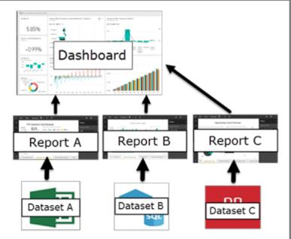

**Microsoft Power BI**

One of the powerful BI vendors is power BI developed by Microsoft. It is capable of collecting complete data from various data sources, rationally organizing and visualizing data, then

quickly sharing outcomes with users. Instead of relying on IT department or data administra

tors in an organization, power BI provides self-service for end users to establish reports and

dashboards by themselves. In other words, power BI is a less technical-oriented business intel

ligence tool and it is user-friendly for beginners.

**An Overview of Power BI**

Power BI is a cloud-based business analytical and visualizing tool for business users to monitor business performance and interact with data. It allows to connect data from local files, Mi

crosoft share points, enterprise data warehouse and other sources. In addition, for Excel users, they can publish the insights created in Excel to power BI, such as pivot tables, dashboards. In other words, power BI encompasses four traditional excel add-ins: power query, power pivot, power view and power map which is user-friendly to those who are accustomed to use excel (Microsoft 2018). There are three components included in power BI services: power BI desktop, power BI ser

vice, and power BI mobile app. Power BI desktop has the strongest integrated abilities to con

nect, transform and visualize data. After connecting with data sources, imported data can be

transformed and cleansed in query editor. Then, users build data model, visualise data

through creating reports or dashboards, and publish finally. Usually, users publish visualized

contents in power BI service. It is also convenient for users to make changes and manage visualiased outcomes based on requirement. In terms of power BI mobile application, it can be

downloaded and installed on Android or IOS devices. Without limitations of time and locations, users can directly view and interact with published data (Microsoft 2018).

The way to use power BI services depends on the user’s role in a team or an organization. For example, the colleague who mainly works with data processing and reports creation might prefer power BI desktop, while another sales executive whose job is to monitor the progress of sales work and get insight into a new sales opportunity primarily chooses mobile app.17These three services collaborated with each other provide a holistic business intelligence solution for users in different business scenarios (Microsoft 2018).

**From Excel Add-in to Power BI**

Before the releasing of power BI, Excel is the primary choice for statistical analysis. No matter what the size of dataset it is, Excel can support to process data, design graphics and charts for business users. To strengthen the ability of analysis, Microsoft has gradually released several add-ins integrated into Excel that are power query, power pivot, power view and power map.

Power Query is a technology for connecting with data sources, shaping data to meet requirements. User can transform data facilitated by query editor. Each transforming step would be

documented appearing in the list, and users are able to view each step and change the names of steps. As for advances query editor, users can type their own conversion by M language.

Power pivot, as a data modelling add-in, is to build relationships among tables, create data models and calculations. According to Clark (2017), sometimes, there is a dilemma in business

analytical scenarios caused by a rigid analysis in data warehouse and a loose analysis in isolated Excel worksheets. Conducting an analysis in data warehouse requires a long-run support

from IT department, while analysis based on Excel worksheets cannot ensure the validity and security issues of data. Therefore, extracting data from data warehouse and analysing them

through power pivots can increase work effectiveness and decrease IT involvement. Power View and power map are data visualization technology for designing interactive charts,

graphs, 3-D maps and other appropriate visualized effects. Based on the visualization, business executives can timely view the trend and identify the problems. Meanwhile, decision

makers carry out solution to solve problems and improve business performance. According to Microsoft (2018), the four add-ins mentioned above are integrated into power BI

services. In power BI desktop, data are collected from varying sources, get transformed and cleansed in query editor. All the changes would be applied into data modelling section called

“Model Designer” (Clark 2017). Similar to power pivot in Excel, users are allowed to build relationships, create calculated columns, measures for deeply exploring valuable information

behind data. Then, users design, customize visualizations, share the results within an organization or a larger group. To get an ideal business intelligence solution, users may spend majority of time on working with power BI desktop. Simultaneously, depending on different roles in a work process flow, users also utilize online service and mobile app to enrich the whole

solution

**Building Blocks of Power BI**

Powell (2018) states that a business team, in a self-service BI approach, owns the greatest flexibility to control dataset and visualization layer and to tailor business intelligence solution, while BI center or IT department provides technical support as a supplementary role. To create helpful reports or dashboards for management-level use, it is imperative to get clear about the four building blocks of power BI: visualization, dataset, report, dashboard and the relationships among them.

**Visualization**

Microsoft (n.d.) generally defines visualization is to visually display collected data by using various charts, graphs or other visualization types. Nowadays, people rely on data visualiza

tion in business intelligence solutions increasingly. Comparing with directly facing a large amount of complex data, humans are better at processing visualized data representation, for example, as a pie chart or a histogram. With the facilitation of computer graphics processing technology, data visualization tools support users to more easily comprehend the periodic business performance, view trend and carry out relative action plans quickly.When conducting a data visualization project, visualization designers should think how to make users to access to data in a comprehensible way. The ultimate objective for data visualization is to effectively deliver information and knowledge to decision-makers without a misleading. Therefore, comprehensibility, applicability and choosing appropriate visualization types are extremely critical (Mckay 2018).

**Dataset, Report and Dashboard**

In terms of a power BI dataset, it is a data model empowering data queries, relationships among fact tables and dimensional tables, and measures (Powell 2018). Dataset is also defined as a collection of data from multiple data sources. Power BI includes abundant data connectors, which enables user to combine various data from Excel files, SQL database and other sources and then to create a dataset (Microsoft 2018).

After creating a dataset, users can design reports or dashboards. A power BI report is a collection of visualization types designed on several pages. The report is usually designed through power BI desktop and published in online services, and users are able to view it via power BI application on mobile devices (Microsoft 2018). It is necessary for designers to conduct a re

port planning before design work, such as getting clear about the targeted users, business questions and creating a supportive dataset. Therefore, the report can be ensured to align with end users’ requirements (Powell 2018).

**Connection of datasets, reports and dashboards**

Similar to report, dashboard is a communicating means to display data extracted from report . One of typical differences is that dashboard only contains single page, which means that the presenting information is more concise and targeted. In a rapidly changing business environment, a timely dashboard creates added value for quickly managing performance, acquiring and comprehending information (Microsoft 2018).

To design a valuable dashboard, there are multiple elements that should be focused. Firstly, Skorka (n.d.) indicates that a dashboard should provide accurate contents related to users. Decision makers explore the information hidden in complex data. Therefore, visualized data on dashboard is the critical source for making decision. Before designing dashboard, designer need identify what data are required by users. Secondly, Skorka (n.d.) highlights the importance for choosing appropriate visualized techniques to help users easily understand data.

Dashboard delivers data and information to users, like a storyteller. It is necessary for dashboard to provide a clear and intuitive view. Thus, users have no more barriers to interpret

contents (Colhoun & Srinivasan n.d.). Thirdly, designer should identify the users of the dashboard. Such as the size and type of users, when and where users utilize dashboard. Based on them, it is clearer to create user scenarios and customize dashboard. Simultaneously, as the dashboard has a limited space, a combination of graphics and texts should be the most representative and can accurately deliver the valuable information to executives or managers. It

needed, detailed data can be provided through supplementary reports (Colhoun & Srinivasan n.d.). Finally, dashboard is not enough as a tool to display data and to inform users. It is im

perative to trigger actions. Users gain insights in terms of a deep understanding of current situation and business problems from dashboard. Based on them, users should take actions to

solve problems and make improvement, which is essential value of a dashboard (Skorka n.d.).20

**User-centric Design of Dashboard**

In user-centric design, gathering users’ requirements is the initial step to acquire customers’

demands by using effective methodologies. In this thesis project, qualitative interview and benchmarking are selected to collect Messko employees’ requirements of new sales dash

board.

**Introduction:**

In the ever-evolving landscape of contemporary data analytics, the role of data-driven decision-making has become pivotal for success across various domains. Advanced analytics tools have revolutionized the interpretation and utilization of data, and this internship embarks on an exploration into the realm of housing price analysis. The specific focus lies in the creation and utilization of a Housing Price Dashboard using Power BI. In the dynamic market of real estate, where conditions fluctuate rapidly, having real-time insights is crucial for making informed decisions. The Housing Price Dashboard serves as a visual compass, navigating through complex housing data to provide stakeholders with a comprehensive and accessible overview of key metrics. Power BI, a leading business analytics tool, empowers organizations to transform raw data into actionable insights, fostering a data-centric culture. This internship aims to delve into the capabilities of Power BI in synthesizing vast datasets, uncovering patterns, and presenting information in an intuitive manner. By exploring the intricacies of creating a Housing Price Dashboard, this report will elucidate the process of translating complex housing data into visually compelling and easily interpretable metrics. The dashboard, as a focal point, not only facilitates a holistic view of housing prices but also equips decision-makers with the tools necessary to identify trends, set targets, and optimize strategies for informed decision-making.

**Abstract:**

In the era of digital transformation, businesses are increasingly reliant on data-driven strategies to navigate the complexities of the modern marketplace. This internship delves into the realm of housing price analysis, focusing on the development and implementation of a Housing Price Dashboard utilizing Microsoft Power BI. The dashboard serves as a visual analytics tool, consolidating intricate housing data into comprehensible insights to empower decision-makers. The primary objective of this internship is to explore the capabilities of Power BI in synthesizing, analyzing, and presenting housing data in a visually engaging manner. Through hands-on experience, the intern aims to decipher the nuances of dashboard creation, emphasizing the importance of real-time, actionable insights in the fast-paced world of real estate. The Housing Price Dashboard, at its core, seeks to streamline the decision-making process by offering a consolidated view of key metrics. This abstract provides a glimpse into the internship's exploration of the technical aspects of dashboard development, the challenges encountered, and the invaluable insights gained into the dynamics of housing price analytics.

**Project Overview:**

Housing Price Dashboard using Power BI In the pursuit of operational excellence and strategic decision-making in the real estate market, the project focuses on the creation and implementation of a Housing Price Dashboard using Microsoft Power BI. This endeavor emerges from the recognition that in today's highly competitive real estate landscape, success hinges on the ability to swiftly interpret and act upon vast and dynamic datasets. The Housing Price Dashboard serves as a centralized hub for visualizing critical housing metrics, facilitating a data-driven approach to real estate analysis. In the ever-evolving landscape of business intelligence, the Housing Price Dashboard project represents a focused exploration into the integration of Microsoft Power BI for the enhancement of housing price analytics. At its core, the project seeks to leverage the robust capabilities of Power BI to transform raw housing data into actionable insights. With the overarching goal of empowering decision-makers, the project delves into the intricate process of constructing a dynamic dashboard that distills complex datasets into visually compelling and easily interpretable metrics.

**Objectives:**

The overarching objectives of this project are to explore the capabilities of Power BI in synthesizing diverse housing data sources, constructing an intuitive and interactive dashboard, and leveraging visualizations to communicate insights effectively. Specific goals include the identification of key housing metrics, the establishment of data connections, and the development of a dynamic dashboard that adapts to the evolving needs of real estate analysis. The primary objectives are two-fold: to unravel the potential of Power BI in handling diverse housing data and to craft a Housing Price Dashboard that provides a real-time snapshot of key metrics. By identifying and prioritizing relevant metrics, the project aims to facilitate strategic decision-making, offering stakeholders a comprehensive and intuitive platform for interpreting housing trends and patterns.

**Scope of Work:**

The project encompasses a comprehensive examination of the housing data lifecycle, from data extraction and transformation to the development of visually compelling reports. It involves the integration of various data sources, such as property information, sales transactions, and market trends, to provide a holistic view of housing prices. The scope also extends to the exploration of Power BI functionalities, including data modeling, DAX calculations, and the creation of interactive dashboards. The scope of the project spans the entire data analysis lifecycle, commencing with data extraction, transformation, and loading (ETL), and culminating in the development of an interactive dashboard. This comprehensive approach involves integrating disparate data sources to present a holistic view of housing prices. The exploration of Power BI functionalities, encompassing data modeling and the creation of dynamic visualizations, will be integral to the project's success.

Modules of the Housing Price Dashboard Project: The project unfolds through a series of interrelated modules, each designed to contribute distinct elements crucial to the development of a robust Housing Price Dashboard using Power BI. Data Integration Module: The Data Integration Module initiates the project, focusing on the comprehensive collection of data from various sources, including property databases and sales records. This module employs sophisticated extraction and transformation techniques to ensure data accuracy and consistency before its integration into Power BI. Data Modeling Module: Following data integration, the Data Modeling Module takes center stage. Here, the relational approach is paramount, with Power BI's robust data modeling capabilities leveraged to establish connections between disparate datasets. Calculated columns and measures, powered by Data Analysis Expressions (DAX), form the backbone of key metrics essential for insightful analytics. Visualization Module: Moving into the visualization realm, the Visualization Module emphasizes the selection and implementation of effective visualizations. Using Power BI's versatile library, this module transforms complex housing data into clear, interpretable visuals, ranging from dynamic charts to geographic representations, enhancing the accessibility of critical housing metrics. Interactive Elements Module: The Interactive Elements Module complements the visualization aspect by introducing user-centric features. Slicers, filters, and drill-through functionalities empower users to dynamically interact with the data, offering a tailored and engaging exploration experience within the dashboard. Dashboard Design Module: Simultaneously, the Dashboard Design Module ensures that the user interface is intuitive and aesthetically pleasing. This involves thoughtful structuring of visualizations, prioritizing clarity, and optimizing the layout to enhance user understanding and engagement. Updates Module: Real-time relevance is addressed in the Updates Module, which configures the dashboard for live data updates. Power BI is configured to connect to live data sources, ensuring that the Housing Price Dashboard provides up-to-the-minute insights to facilitate timely decision-making. User feedback becomes paramount in the User Testing and Feedback Module, where stakeholders and end-users engage in systematic testing sessions. This iterative process allows for the identification of areas for improvement, shaping the subsequent phases of development. Refinement and Iteration Module: The Refinement and Iteration Module embraces continuous improvement based on user feedback. By iterating on design, functionality, and overall performance, this module ensures that the Housing Price Dashboard evolves to meet the dynamic needs of users and the real estate environment. Training and Deployment Module: Finally, the project concludes with the Training and Deployment Module, focusing on user adoption and strategic deployment. Training sessions equip end-users with the skills to navigate and interpret the Housing Price Dashboard effectively, ensuring that the deployment phase is accompanied by the necessary support and documentation for seamless integration into the real estate workflow. Together, these interconnected modules form a holistic approach to the creation of a powerful Housing Price Dashboard, seamlessly blending technical intricacies with user-centric design principles to drive data-driven decision-making within the realm of real estate analytics.

**Methods:**

The development of the Housing Price Dashboard using Power BI involves a methodical and iterative approach, combining sophisticated data processing, insightful analysis, and engaging visualization techniques. The methodology unfolds across several interconnected phases to ensure a comprehensive and effective creation process. Data **Collection and Processing:**

The initial phase centers around data collection from diverse sources, including property databases, sales records, and external market data. Rigorous data cleaning procedures are implemented to address inconsistencies, outliers, and missing values. This phase lays the foundation for a reliable dataset, setting the stage for subsequent analysis and visualization. Data Modeling and Transformation: The second phase focuses on data modeling within Power BI. Utilizing the platform's advanced capabilities, relational data models are established, defining connections between various data tables. Key metrics are formulated using Data Analysis Expressions (DAX) to enable meaningful insights. This phase is critical for transforming raw data into a structured format conducive to effective analysis. Visualization Techniques: With a refined dataset in place, the project moves into visualization techniques. Leveraging Power BI's extensive library, visualizations are chosen based on their ability to effectively represent key metrics and trends. Graphs, charts, and geographical maps are tailored to provide a clear and intuitive understanding of housing prices.

**Interactive Elements and User Experience:** The fourth phase introduces interactive elements to enhance user engagement and exploration. Slicers, filters, and drill-through functionalities are implemented to empower users to dynamically interact with the data. User experience is a focal point, ensuring that the Housing Price Dashboard is not only informative but also user-friendly and adaptable to varying analytical needs. Dashboard Design Principles: The project then transitions into the design phase, where principles of intuitive dashboard design are applied. The layout is carefully crafted to prioritize clarity and ease of interpretation. Visualizations are organized logically, creating an aesthetically pleasing and navigable dashboard. Updates: Ensuring the dashboard remains relevant in a dynamic real estate environment, the sixth phase involves configuring real-time data updates. Power BI is set up to connect to live data sources, facilitating continuous updates and ensuring stakeholders have access to the most current housing information. User Testing and Feedback Gathering: User testing becomes integral in the seventh phase. Stakeholders and end-users engage in systematic testing sessions to evaluate the functionality and usability of the dashboard. Feedback is collected to identify areas for improvement, ensuring that the final product aligns closely with user expectations. **Refinement and Iteration Process:**

An iterative refinement process follows, guided by user feedback. The eighth phase involves making necessary adjustments to the dashboard's design, functionality, and overall performance. This iterative approach allows for continuous improvement, adapting the dashboard to the evolving needs of users and the dynamic real estate landscape. Documentation and Knowledge Transfer: Comprehensive documentation is generated throughout the development process, detailing data sources, transformations, and Power BI configurations. This documentation serves as a valuable reference for future endeavors and supports knowledge transfer within the real estate organization.

**Training and Strategic Deployment:** The final phase focuses on user adoption and strategic deployment. Training sessions are conducted to ensure end-users possess the skills to navigate and interpret the Housing Price Dashboard effectively. The dashboard is deployed strategically, accompanied by the necessary support and documentation for seamless integration into the real estate workflow.

**Hardware Specification:** ✓

* PROCESSOR: PENTIUM IV ✓
* RAM: 8 GB ✓
* PROCESSOR: 2.4 GHZ ✓
* MAIN MEMORY: 8GB RAM ✓
* PROCESSING SPEED: 600 MHZ ✓
* HARD DISK DRIVE: 1TB ✓
* KEYBOARD: 104 KEYS

**Software Specification:**

* TOOL: MICROSOFT POWER BI DESKTOP
* VERSION: 2.118.828.0 32-bit (June 2023)

**Overview of POWER BI:** In the dynamic landscape of data analytics and business intelligence, Power BI stands as a beacon of innovation, empowering organizations to transform raw data into actionable insights. Developed by Microsoft, Power BI is a comprehensive suite of business analytics tools that seamlessly integrate with various data sources, enabling users to visualize and interpret data in ways that were once considered complex and time-consuming. At its core, Power BI is a robust platform that facilitates end-to-end data analytics, from data preparation to insightful visualization. Its intuitive interface and drag-and-drop functionality make it accessible to users with varying levels of technical expertise, democratizing data analytics across organizations. Power BI allows users to connect to a multitude of data sources, including databases, Excel files, cloud services, and streaming data, fostering a unified approach to data integration. One of Power BI's standout features is its versatile set of visualization tools. Users can create interactive and compelling reports and dashboards with a diverse range of charts, graphs, and maps. These visualizations go beyond mere data representation; they serve as a conduit for uncovering patterns, trends, and outliers, providing stakeholders with a clear understanding of their data landscape. Power BI doesn't stop at visualization; it delves into the realm of advanced analytics with the integration of machine learning capabilities. Users can leverage built-in machine learning models or seamlessly integrate custom algorithms, opening new avenues for predictive analysis. This functionality empowers organizations to forecast trends, make informed decisions, and stay ahead in an ever-evolving market. Collaboration lies at the heart of Power BI's design philosophy. The Power BI service enables users to share reports and dashboards securely, fostering collaboration among team members. With real-time updates and the ability to embed reports into applications, Power BI ensures that insights are not confined to the analytics department but are disseminated throughout the organization. The impact of Power BI is best showcased through real-world applications. Organizations across industries leverage Power BI to gain a competitive edge. From housing price dashboards that provide real-time insights into market trends to investment analytics that optimize financial portfolios, Power BI has become a transformative force in the business decision-making process. Looking ahead, Power BI is poised to continue its evolution, embracing emerging trends such as augmented analytics, natural language processing, and increased integration with artificial intelligence. The democratization of data is set to reach new heights, with more users across organizations harnessing the power of data analytics to drive innovation and foster a culture of data-driven decision-making. In conclusion, Power BI transcends being merely a business intelligence tool; it represents a paradigm shift in how organizations approach and derive value from their data. With its user-friendly interface, advanced analytics capabilities, and emphasis on collaboration, Power BI is not just a tool; it's a catalyst for transformation, ushering in a new era of data-driven excellence.

**Results:** The implementation of Power BI has yielded transformative results, redefining how organizations harness and leverage their data to drive decision-making in the real estate sector. With the seamless integration of diverse housing data sources and the creation of intuitive, interactive dashboards, Power BI has become a linchpin in uncovering actionable insights in the housing market. Stakeholders are now equipped with a panoramic view of key metrics, enabling them to make informed decisions with unprecedented speed and accuracy. The impact of Power BI is evident in the tangible outcomes achieved across various facets of real estate operations. Real estate professionals benefit from real-time housing price dashboards, allowing for agile responses to market dynamics and the identification of lucrative opportunities. Property developers leverage advanced analytics to forecast trends, enabling proactive strategies in a competitive market. Finance departments within real estate organizations utilize predictive analytics for investment decisions, resulting in optimized financial portfolios. The democratization of data through Power BI's collaboration features ensures that decision-makers at all levels are equipped with the information needed to contribute to organizational success.